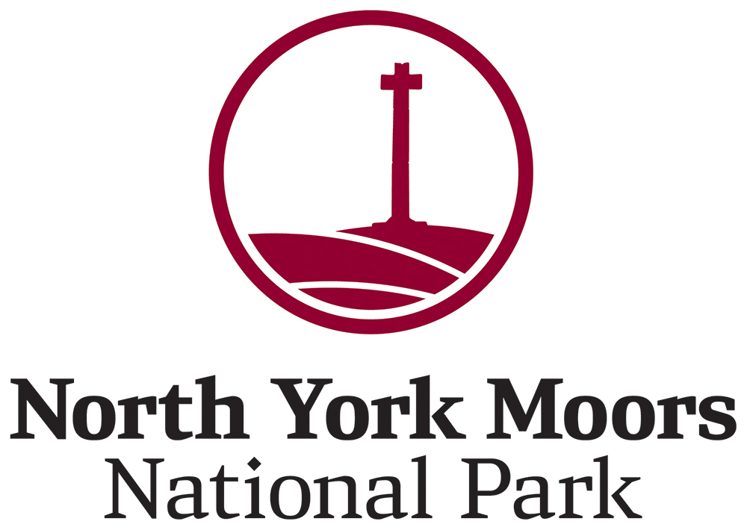

# Job description

Post of Engagement Trainee – Championing National Parks for Everyone

Post number - RW339

Grade A fixed term contract of 10 months, 4 days per week/30 hrs includes some evening and weekend working (March 2025 – December 2025 )

Recreation and Wellbeing Department

Responsible to Head of Engagement and Wellbeing with additional support provided by the CNPfE Project Officer

Work base – Danby Lodge National Park Centre, YO21 2NB

## Purpose

This traineeship will sit within the North York Moors National Parks Authority’s Engagement and Wellbeing Team. The primary focus of this role is to help deliver the Championing National Parks for Everyone (CNPfE) project. Peak District Mosaic has been awarded a grant from The National Lottery Heritage Fund to deliver the Championing National Parks project in partnership with National Park Authorities.

The main aim of the CNPfE project is to deliver a range of opportunities to support people from diverse communities to visit, enjoy and work in the National Parks. This aim will be addressed by delivering the Community Champion Training programme, which supports participants to gain the skills and knowledge for them to run safe and enjoyable activities within the National Park for friends, family and community members.

This traineeship will support the Project Officer to work with diverse communities living in Teesside. The trainee will help to recruit participants to the Community Champion Training programme, and to assist in planning and delivering activities at community outreach events, during the training programme, and during the monthly activity events within the North York Moors. The trainee will develop skills and confidence in working with communities and working in the environmental sector.

## During the traineeship you will;

1. Learn how to plan and run successful outdoor activities in the National Park, including considering how to address the barriers faced by different groups and how to manage health and safety.

2. Communicate and work alongside people as equal partners, building trust and rapport to help them identify what matters to them, building on their strengths to improve health and wellbeing in the outdoors and understanding effective methods of engagement.

3. Assist in the preparation and delivery of activities that support people from diverse communities to visit the National Park with their needs at the foreground, working under the direction of the Project Officer

4. Undertake work projects related to your interests which are agreed with your manager that support our overall project aims. For example, this could include designing and delivering your own activity day; creating a video or other digital resource to support visitors from diverse backgrounds.

5. Contribute to our project’s overall monitoring and evaluation, helping to collect data from people taking part in activities and reflecting on successes and challenges.

6. Have the opportunity to work shadow other teams in the National Park, related to your areas of interest that engage with and work with the public. This could include Rangers, Rights of Way team, Visitor Services, Marketing and Communications.

7. Meet regularly with your manager to review your personal development plan, assessing what skills you want to gain and what additional training you wish to attend and receiving support on how to gain your next role within the sector

8. Ensure that all work is carried out in the spirit of the Authority’s corporate values and in accordance with the current Health and Safety and Equalities policies.

9. Undertake any other duty consistent with the grade of the post which the Head of Engagement and Wellbeing might reasonably request.

All staff are expected to attend at least two days of volunteering each year. This can be joining any volunteering task, taking part in a supertask or going on one of the director training days.

# Person specification

This is a role to help you start a career in the outdoor sector. You may have done some prior work engaging people in the youth, community, social care, health and wellbeing or sports sectors. You will be motivated to help us ensure that the National Parks are for everyone to be able to visit and enjoy.

Your previous experience does not matter – the important thing is that you are interested in working with us in the North York Moors National Park and that you are interested in building your career in the outdoors / environment sector - especially in roles that engage people and communities.

You do **not** need any specific qualifications or prior experience in the outdoors for this role. We welcome people with a wide range of backgrounds and interests to apply for the role.

| Experience and knowledge | Essential | Desirable |
| --- | --- | --- |
| Some experience and a keen interest in engaging and working with people from diverse communities – whether gained through volunteering or work | Yes | - |
| Some IT skills or willingness to learn how to use Teams, Word, Excel and PowerPoint | Yes | _ |
| Some experience of activity and resource development that is inclusive, equitable and accessible. | _ | Yes |
| Some experience of delivering engagement through a range of channels e.g. face to face, workshops, through partner networks and online material | - | Yes |
| Some experience with communities/individuals with English as an additional language. | - | Yes |
| Some experience and knowledge of health and safety and safeguarding policies and procedures | - | Yes |

| Communication skills | Essential | Desirable |
| --- | --- | --- |
| Excellent communication and interpersonal skills, with the ability to connect with a wide range of people. | Yes | - |
| Enthusiasm and making sure that our National Parks and outdoor spaces are for everyone. Modelling this through own resilient and encouraging behaviour when working outdoors with diverse communities. | Yes | - |

| Self-management | Essential | Desirable |
| --- | --- | --- |
| Good time management skills, ability to prioritise and work under own initiative. | Yes | - |
| Good organisational skills. | Yes | - |

| Personal attributes | Essential | Desirable |
| --- | --- | --- |
| Interest in building a career in the outdoors/environment sector – especially in roles that engage people and communities. | Yes | _ |
| Must have the ability to travel to locations both within and outside of the National Park to carry out the job requirements. | Yes | - |
| Strong team working ability. | Yes | - |
| A level of physical fitness appropriate to the post. | Yes | - |
| A keenness for working outside | Yes | - |
| Flexible attitude to working hours and days. The job will include occasional weekend working with prior discussion. | Yes | - |

### Pay

The hourly rate is £12.26

### Travel Bursary

A flat rate of £50 per week is provided to support your travel costs to your work base at Danby Lodge National Park Centre.

### Training

We are committed to developing your skills and experience throughout the duration of the traineeship. The direction of this development will be steered not only by the needs of the role but also through talking with you about what your future career aspirations are. There is a significant training budget with the role to support this.

There will be some standards elements which will include:

* Outdoor First Aid (2 day)
* Safeguarding
* Basic Navigation
* Health and safety
* Mental health first aid
* Internal training on policies and practice using the National Parks ELMS online training platform

Through discussion with your manager we will work out what other training you will undertake to develop your career. This could include (but is not limited to):

* Level 2 Forest School Assistant
* Level 2 Leader in Outdoor Learning
* Coastal Activity Leader Training
* Woodland Activity Leader Training
* Hill and Moorland Leader Training with Mountain Training England
* Any other course within budget which will meet your learning needs.

### Values

Our Values reflect the way in which we all deliver our work and interact with people. The Values are visible in our work, and we hold each other to account for them, celebrate when we demonstrate them, and use them to help us make decisions and consider our priorities.

* Proud: We are proud to be a part of an organisation that conserves, enhances and champions this spectacular landscape – each of our roles makes this possible.
* Professional: We are doers, enablers, inspirers - we uphold the highest professional standards to bring about positive change for the National Park.
* Welcoming: Inclusivity and empathy are at the heart of who we are and what we represent - the National Park is a place for all.
* Collaborative: We work positively and proactively with others to achieve our shared vision of the North York Moors.

### Conditions of service

The appointment is based at Danby Lodge National Park Centre. Hours are 9.00 am to 5.00 pm and there is an expectation that some of this work will take place on evenings and weekends. A flexitime system is in operation.

The postholder will be eligible to join the Local Government Pension Scheme. Full details of the LGPS, together with information about how to join, will be sent to the successful applicant.

New starters will be entitled to 25 days annual leave rising annually by one day, to 30 days after 5 years service, plus eight public holidays. The leave year runs from April to March.

A pool car system is in operation. You, in the first instance, have access to a pool car but, in the event of its unavailability, will be reimbursed a mileage rate for use of their own vehicle for those times when it is necessary to use a private car in carrying out the official duties of the post.

### Selection and interviews

We will be running an informal open session via an online webinar on Microsoft Teams to allow interested candidates to hear from the team and find out more about the role.

There are two options to attend on either:

[Tuesday 14th January 2025 from 12:00 – 12:30](https://events.teams.microsoft.com/event/7ff355b8-8ab4-4032-9a98-433c4df2ed6e@2d56c221-4118-42b6-aa24-82d7f976ac6c)

[Thursday 16th January 2025 from 19:00 – 19:30.](https://events.teams.microsoft.com/event/f3e9c7e2-fbed-4656-8190-e69f7c02e9ea@2d56c221-4118-42b6-aa24-82d7f976ac6c)

You do not have to attend a session to apply for the role. If you are interested in attending, please use the hyperlinks provided to register your place.

Please note that the camera and microphone functions will be disabled but you will be able to ask questions via the chat function.

If you wish to apply, you will need to fill in the short application form which includes the following questions:

1. Why are you interested in this role and how will you use the skills developed through this traineeship in the future? (Maximum of 200 words)

2. Through your interest and/or experience, why do you think outdoor spaces (including National Parks or local green spaces) are important for everyone to access? (Maximum of 200 words)

3. Please tell us about your experience of belonging to and/or working with diverse audiences in community groups. (Maximum of 200 words)

If you are successful at the first stage, you will be invited to a 15-minute discussion via WhatsApp video call. If you are successful at this second stage, you will be invited to an interview day where we will ask you to make a 5-minute presentation that you have prepared in advance and ask you some more questions.

For an informal discussion about the role please contact Jayney Barnard, Project Officer for Championing National Parks for Everyone on 01439 772700 or email [j.barnard@northyorkmoors.org.uk](mailto:j.barnard@northyorkmoors.org.uk)

Applications must be completed by midnight on **Sunday 26th January 2025**

**Anticipated interview date – Tuesday 25th February 2025**

