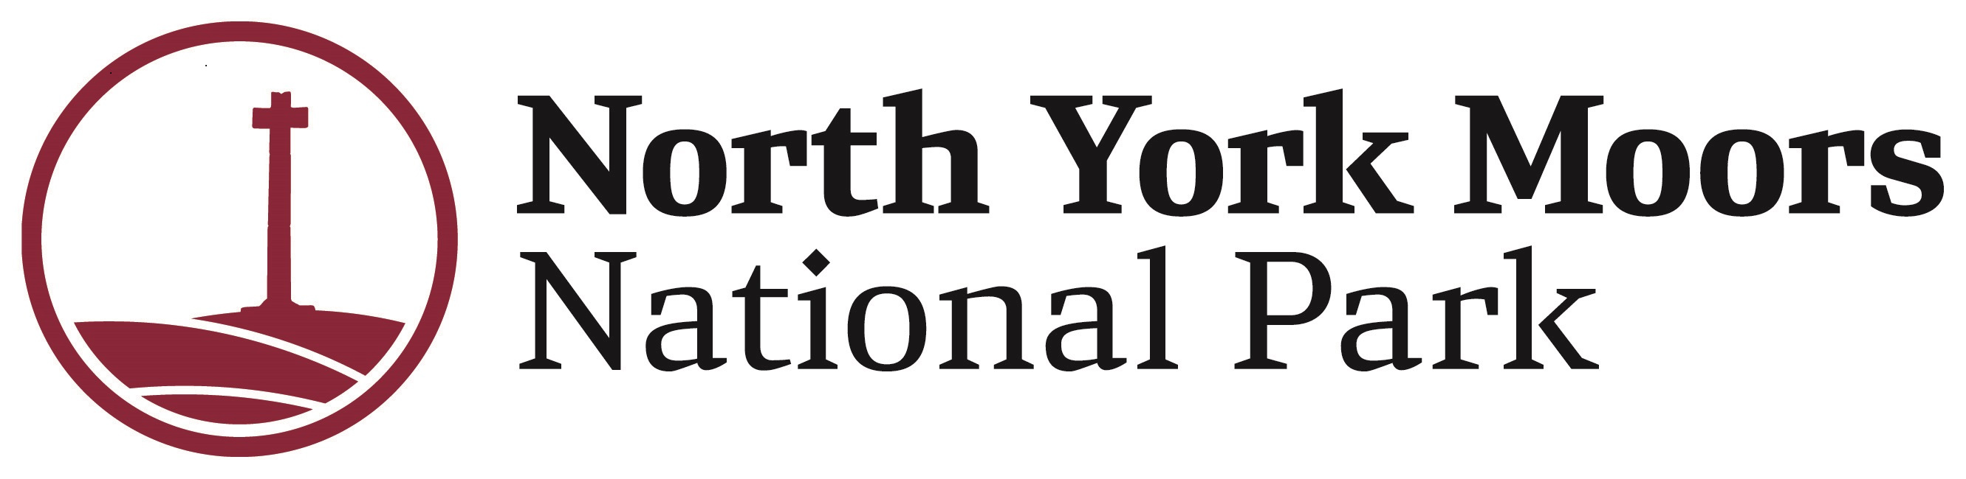

# Championing National Parks for Everyone Traineeship

### About Championing National Parks for Everyone

Championing National Park for Everyone (CNPfE) is a project run by the charity Peak District Mosaic in collaboration with the North York Moors, Peak District and Yorkshire Dales National Park Authorities, and Derbyshire Dales CVS.

Peak District Mosaic has been awarded a grant from The National Lottery Heritage Fund to deliver the Championing National Parks project in partnership with National Park Authorities.

This is an exciting opportunity to work on a project that will deliver a range of opportunities to support people from diverse communities to visit, enjoy and work in the National Parks. We will especially work with diverse communities living in urban areas near to the National Parks, including Teesside.

The heart of the project is the Community Champion Training programme, which supports participants to gain the skills and knowledge for them to run safe and enjoyable activities within the National Park for friends, family and community members. This builds on the success of previous projects and aims to leave a successful legacy of Community Champions who will support others to visit in the future and who will be supported by the charity Peak District Mosaic.

### About you

This is a role to help you start a career in the outdoor sector. You may have done some prior work engaging people in the youth, community, social care, health and wellbeing or sports sectors. You will be motivated to help us ensure that the National Parks are for everyone to be able to visit and enjoy.

Your previous experience does not matter – the important thing is that you are interested in working with us in the North York Moors National Park and that you are interested in building your career in the outdoors/environment sector – especially in roles that engage people and communities.

We will be running an informal open session via an online webinar on Microsoft Teams to allow interested candidates to hear from the team and find out more about the role.

There are two options to attend on either:

[Tuesday 14th January 2025 from 12:00 – 12:30](https://events.teams.microsoft.com/event/7ff355b8-8ab4-4032-9a98-433c4df2ed6e@2d56c221-4118-42b6-aa24-82d7f976ac6c)

[Thursday 16th January 2025 from 19:00 – 19:30.](https://events.teams.microsoft.com/event/f3e9c7e2-fbed-4656-8190-e69f7c02e9ea@2d56c221-4118-42b6-aa24-82d7f976ac6c)

You do not have to attend a session to apply for the role. If you are interested in attending, please use the hyperlinks provided to register your place.

Please note that the camera and microphone functions will be disabled but you will be able to ask questions via the chat function.

If you wish to apply, you will need to download the short application form which includes the following questions:

1. Why are you interested in this role and how will you use the skills developed through this traineeship in the future? (Maximum of 200 words)

2. Through your interest and/or experience, why do you think outdoor spaces (including National Parks or local green spaces) are important for everyone to access? (Maximum of 200 words)

3. Please tell us about your experience of belonging to and/or working with diverse audiences in community groups. (Maximum of 200 words)

If you are successful at the first stage, you will be invited to a 15-minute discussion via WhatsApp video call. If you are successful at this second stage, you will be invited to an interview day where we will ask you to make a 5-minute presentation that you have prepared in advance and ask you some more questions.

For an informal discussion about the role please contact Jayney Barnard, Project Officer for Championing National Parks for Everyone on 01439 772700 or email [j.barnard@northyorkmoors.org.uk](mailto:j.barnard@northyorkmoors.org.uk)

Applications must be completed by midnight on **Sunday 26th January 2025**

**Anticipated interview date – Tuesday 25th February 2025**