

**Views of North East Ambulance Service**

**1.**

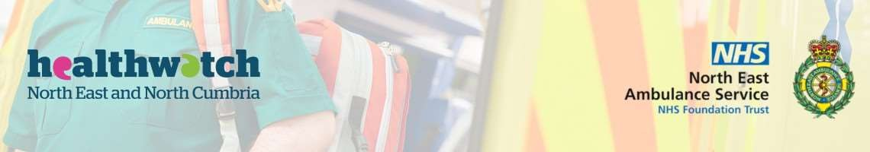

Healthwatch helps to make local health and care services better for you. We do this by finding out your views and experiences of health and care services and feeding this back to the people delivering and designing services, so they can be improved for all residents.

**The North East Ambulance Service (NEAS) have asked us to help them find out people's views about their services. This will help them design and plan their services for the future. Their work includes:**

* **Ambulances and paramedics**
* **Patient transport service**
* **999 call handling**
* **NHS111 calls**

While most people think about the North East Ambulance Service as ambulances responding to 999 calls, nearly two­thirds of their work is answering calls to NHS111. From life­threatening emergencies to general health advice NEAS plays a key role in the North East health system. The information you provide will be stored safely and will be used anonymously to help us work to improve local services.

The network of local Healthwatch organisations across the North East and North Cumbria are coming together to deliver this project. Take a look at our website to find out more about us: <https://www.healthwatchstocktonontees.co.uk/>

At the end of this survey, you will have the opportunity to take part in our prize draw to win £100 of Love2Shop vouchers.

If you have any queries or change your mind about taking part in this survey, please contact email us at [healthwatchstockton@pcp.uk.net](mailto:healthwatchstockton@pcp.uk.net).

If you’d prefer to complete this survey online, scan the QR code, or visit [www.smartsurvey.co.uk/s/NEASviews2024/](http://www.smartsurvey.co.uk/s/NEASviews2024/)

1. **Where do you live?**

County Durham Darlington Gateshead Hartlepool Middlesbrough  Newcastle North Tyneside Northumberland

 Redcar and Cleveland

South Tyneside Stockton Sunderland

Other (please specify):



**2. Views and experiences of North East Ambulance Service**

1. **Have you used the North East Ambulance Service in the last 2 years? (select all that apply). This will help us understand people's points of view.**



Yes – ringing 999

Yes – ringing NHS 111

Yes, using the Patient Transport Service

Not personally, but someone close to me has

Not in the last 2 years

Yes, Ambulance or Paramedic

Never.

You can use this space to tell us more

es ­ using the Patient Transport yes ­ ambulance or ervice paramedic

ever

Yes ­ ringing 999 Yes ­ ringing NHS 111

Not personally, but someone close to m has.

e Not in the last 2 years

Y S

N

1. **What do you think the North East Ambulance Service does well?**
2. **What do you think the North East Ambulance Service could do better? (please be as specific as you can)**
3. **What do you think a good service would be when you contact the Northeast Ambulance Service?**
4. **What is most important to you from an ambulance service? Please put the following items into order of importance, most important first, going down in level of importance, with least important last: Use numbers to do this, with 1 being most important, and 6 least important.**
   * Quick response time
   * Specialist knowledge of your condition
   * Symptom / pain relief
   * Access to the most appropriate service for your care
   * Advice, guidance and information
   * Something else ­ use box below You can use this space to tell us more
5. **Would you expect to be taken to hospital when you call 999?**

 Yes  Maybe  No

Please tell us the reasons for your answer

1. **How could the North East Ambulance Service work with other organisations to improve services, and who are the other organisations we should be working with?**

**All the information you provide will be kept anonymous. We ask these details so that we can ensure we are reaching a range of different people from across the region. You can choose not to answer any of these questions.**

1. **First part of your postcode (eg NE26)**
2. **Gender**

 Man  Woman  Non­binary  Prefer to self­describe  Prefer not to say

1. **Your Age**

Under 18 ­ 24 25 ­ 34 35 ­

18 44

45 ­ 54 55 ­ 64 65 ­ 74 75+



Under 18

18 – 24

25 – 34

35 – 44

45 – 54

55 – 64

65 – 74

75+

1. **Ethnicity**
2. **Do you have a long term health condition?**

Yes No Prefer not to say



Yes

No

Prefer not to say

If 'Yes' please specify

1. **Do you consider yourself to have a disability?**

Yes No Prefer not to say



Yes

No

Prefer not to say

If 'Yes' please specify

1. **Are you a carer?**

Yes No Prefer not to say



Yes

No

Prefer not to say



**4. Contact details**

**Please provide your contact details if you want to enter the prize draw or be contacted in the future by your local Healthwatch. We will only use your details in the way you tell us to.**

1. **How can we use your contact details? Please tick all boxes that apply**

 Contact me if you need more information about my experience   Enter the £100 love2shop voucher prize draw

Send me the free online Healthwatch monthly enewsletter about local health and social care issues for my local area

1. **Your contact details:**

Name:

Phone

number:

E­mail:

(required for e­newsletter)