****Survey:   
Young People & Mental Health

**Healthwatch South Tees** is working to make sure local health and care services are meeting the needs of local people.  We do this by asking people what matters most to them and what improvements could be made.   
  
We know that there are more young people struggling to keep good mental health.  We also know there is a national interest to prevent poor mental health (Public Health England 2017).  
   
**We need you** to tell us what you think are the causes of poor mental health in young people (up to the age of 25).  We also want to know your ideas for stopping young people from developing poor mental health. Please help us by sharing your thoughts and experiences below.   
   
We've also asked a few more questions about you.  This will help us to make better use of the overall information by exploring the different ways mental health can be affected, for example, by age or ethnicity.   
   
We understand how thinking about personal experiences can be very difficult, so we have included some information at the end of this survey which we hope will be useful if you need it.  
   
**Thank you!** Your information is very important to us and will help make a difference to the lives of young people locally.

1. **What do you think are the causes of poor mental health?**

1. **What is this opinion based on?**□ Your own experience □  Someone you know

□ The media □  Public perception

□  Other (please specify)

1. **What do you think would prevent poor mental health in young people?**

1. **Would you be interested in getting more involved in future Healthwatch work around young people and mental health?**

□  No

□  Yes (if so, please provide your contact details below)

1. **Would you be happy for Healthwatch to share your story to help others understand why things need to change?**

□  No

□  Yes (if so, please provide your contact details below)

1. **What is your age?**

1. **What is your gender?**

□ Male

□  Female

□  Other (please specify)

1. **What is your sexuality?**
2. **What is your ethnicity?**
3. **What is your post code? (If you don’t know, you can just say if you live in Middlesbrough or Redcar & Cleveland!)**
4. **Are you: (Please tick those that apply)**

□ A Young Parent □  A Young Carer □ A Refugee

□  An Asylum-Seeker □  A Traveller

1. **Do you have additional needs and / or disabilities?**

□ No

□  Yes

□  Not sure

Please explain:

1. **Do you have any long-term health conditions?**

□ No

□  Yes

□  Not sure  
  
Please explain:

Service Contacts 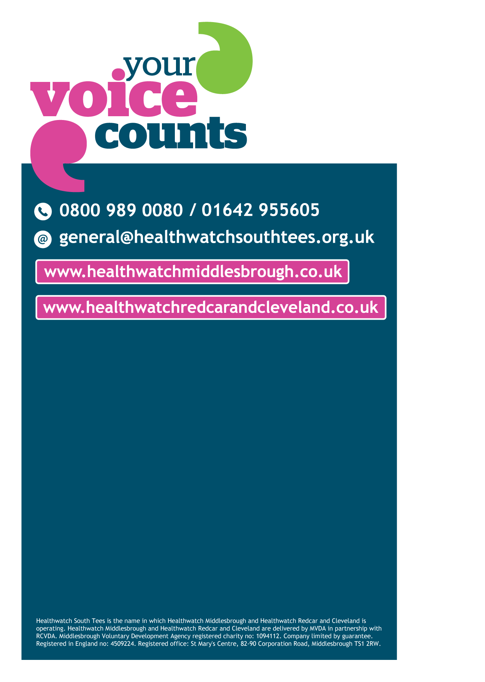

**Childline:**  
Online, on the phone, anytime  
**Tel:** 0800 1111  
**Web:** [www.childline.org.uk](http://www.childline.org.uk)

**Mental health matters:**   
**Confidential helpline offering e**motional support and guidance 7 days a week, from 6pm to 6am  
**Tel:** 0800 052 7350

**Middlesbrough & Stockton Mind**  
**Tel:** 01642 257020 (12pm - 5pm Mon-Thurs; 12pm - 4pm Fri)  
**E-mail**: info@middlesbroughandstocktonmind.org.uk  
**Web**: www.middlesbroughandstocktonmind.org.uk

**Teesside Samaritans:**  
Emotional support on the phone or face to face  
**Tel:** 116 123 Free from any phone  
**Address:** 147 Borough Road, Middlesbrough, TS1 3AT

If you are having an urgent mental health issue, you should contact **your GP straight away.**If you have an urgent mental health issue outside of normal GP practice hours, you can contact the out of hours service.  
**Out of Hours Tel:** 0300 123 1851 (6pm-8am Mon – Thurs; 6pm Fri – 8am Mon; all day Bank Holidays)