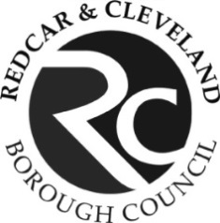**Provision of Substance Use Services**

**SUPPLIER NETWORKING INFORMATION FORM**

Delegates who attended a market consultation event on the 14th March 2017 expressed a wish to share information about their organisation with the market in order to establish an opportunity for possible partnership/consortia working.

If you would like to share your information as part of the tender process please complete the form below providing a brief summary about your organisation (no more than 250 words in total please), and upload it through the Messaging facility on the e-tender system (NEPO portal) before end of business on Monday 16 October 2017. Your completed form will be circulated as part of the tender documents to all interested parties.

**CONSORTIA ARRANGEMENTS**

Redcar and Cleveland Council are unable to provide any advice to organisations on the forming and setting up of consortia (organisations should seek independent advice on this matter) but we are happy to collect the information below from organisations and make it available in the tender documents.  Please note this will be available to other interested parties and available within the public domain.

|  |  |
| --- | --- |
| Organisation Name |  |
| Contact details |  |
| Organisation profile |  |
| Organisation requirements (interested in) |  |