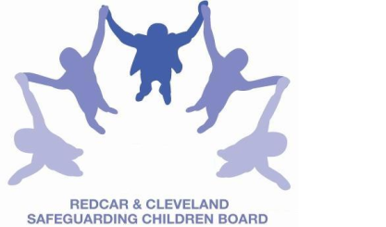
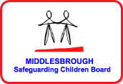
LOCAL SAFEGUARDING CHILDREN BOARD MULTI - AGENCY TRAINING

APPLICATION FORM

Recognition and Response to Physical Injury: Safeguarding Children & Young People
This course will be facilitated by Jane Parkes, Safeguarding Nurse Trainer - South Tees NHS Trust and Mary Griksaitis, Child Protection Officer for Education, Middlesbrough

Date & Time | TUESDAY 21st JUNE 2016
Venue | Bridgeway, Allendale Road, Ormesby, Middlesbrough.  TS7 9LF
Aim | To increase understanding of safeguarding children & young people from physical abuse
Objectives | By the end of the course participants will:  - Consider the latest research findings in relation to physical abuse  - Explore thresholds of concern within a child development context  - Identify key elements for assessing risk in relation to physical abuse  - Consider the emotional impact of physical abuse on children
PLEASE NOTE:
- In accordance with LSCB Charging Policy this course is free to not for profit agencies in the Middlesbrough & Redcar & Cleveland area
- A non-attendance charge of £30 will be incurred if the applicant, having secured a place on the course, does not attend and their manager will be informed of their non-attendance.
- By applying to attend this course you agree to complete an evaluation on the day
and also an impact evaluation approximately 6 months after attending.
Applicant’s Details
Name
Job Title/Role
Organisation
Work Address
Telephone
E-mail

Details of applicant’s manager who agrees applicant can attend and that applicant has received child protection awareness training or refresher within last 3 years.
Name:
Telephone
Manager’s
e-mail address

Completed application form:

- Email to: LSCBtraining@redcar-cleveland.gov.uk
- Apply online at: LSCB Training – Redcar and Cleveland or LSCB Training - Middlesbrough
- Post to: LSCB Training, Seafield House, Kirkleatham Street, Redcar, TS10 1SP.

If you have not heard from us within 7 working days of the course commencing please ring LSCB Training 01642 444336.

