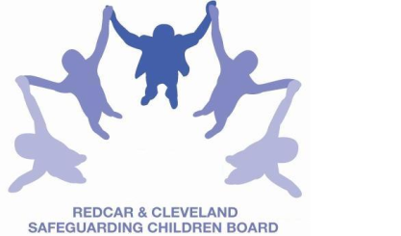
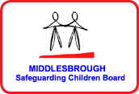

LOCAL SAFEGUARDING CHILDREN BOARD MULTI-AGENCY TRAINING
APPLICATION FORM
EARLY HELP ASSESSMENT TRAINING

This HALF DAY course will be facilitated by: Jeanette Downing and Wendy Nixon, Early Years Professionals, Redcar and Cleveland
Date: | FRIDAY 10th JUNE 2016
Venue | BRIDGEWAY, ALLENDALE ROAD, ORMESBY, MIDDLESBROUGH  TS7 9LF
Aim | To support practitioners, undertaking the Early Help Assessment to understand the world of the child and recognize the need for early intervention.
Objectives | - We will look at gathering information using our curiosity and knowledge, making sense of it, and coming to judgements with the family about the best way forward to meet the child’s emerging needs.  - The training will help practitioners to articulate what they are worried about, why and what needs to be done next in order to support the child and family.  - By exploring the developing world of the child in the Early Help Assessment, we will be able to articulate the impact on the child and make judgements about the possible consequences for the future well-being of the child.
PLEASE NOTE:
- In accordance with LSCB Charging Policy this course is free to not for profit agencies in the Middlesbrough & Redcar & Cleveland area
- A non-attendance charge will be incurred if the applicant, having secured a place on the course, does not attend and their manager will be informed of their non-attendance.
- By applying to attend this course you agree to complete an evaluation on the day
and also an impact evaluation approximately 6 months after attending.
Applicant’s Details
Name
Job Title/Role
Organisation
Work Address
Telephone
E-mail

Details of applicant’s manager who agrees applicant can attend and that applicant has received child protection awareness training or refresher within last 3 years.
Name:
Telephone
Manager’s
e-mail address

Please send completed application form:
- Email to: LSCBtraining@redcar-cleveland.gov.uk
- Apply online at: LSCB Training – Redcar and Cleveland or LSCB Training - Middlesbrough
- Post to: LSCB Training, Seafield House, Kirkleatham Street, Redcar, TS10 1SP.

If you have not heard from us within 7 working days of the course commencing please ring LSCB Training 01642 444336.

